NAME: ARUNAVA DEY
ROLL NO: 11500117123

1.
number=1
rows=5
for((i=1; i<=rows; i++))
do
for((j=1; j<=i; j++))
do
echo -n "$number "
number=$((number + 1))
done
number=1
echo
done

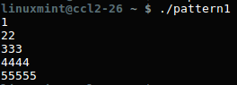

2.
for r in {1..5}
do
for i in $(seq 1 $r)
do
printf "$i "
done
printf "\n"
done

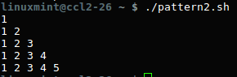

3.

MAX_NO=0

echo -n "Enter Number between (5 to 9) : "
read MAX_NO

if ! [ $MAX_NO -ge 5 -a $MAX_NO -le 9 ] ; then
echo "I ask to enter number between 5 and 9, Okay"
exit 1
fi

clear

for (( i=1; i<=MAX_NO; i++ ))
do
for (( s=MAX_NO; s>=i; s-- ))
do
echo -n " "
done
for (( j=1; j<=i; j++ ))
do
echo -n " $i"
done
echo ""
done
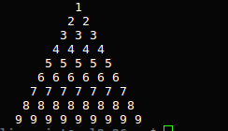

4.
echo "Enter a number"
read num

fact=1

while [ $num -gt 1 ]
do
fact=$((fact * num))
num=$((num - 1))
done
echo "Factorial is" $fact

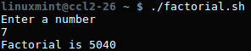

5.

for((i=0;i<5;i++))
do
echo "enter `expr $i + 1` number"
read arr[$i]
done
echo "the numbers you hav entered are"
for((i=0;i<5;i++))
do
echo ${arr[$i]}
done

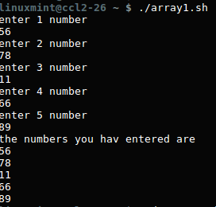

6.
function add()
{
sum=$(($1 + $2))
echo "Sum = $sum"
}

a=10
b=20
add $a $b

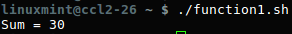

7.
echo "enter maximum number"
read n
echo "enter Numbers in array:"
for (( i = 0; i < $n; i++ ))
do
read nos[$i]
done
echo "Numbers in an array are:"
for (( i = 0; i < $n; i++ ))
do
echo ${nos[$i]}
done

for (( i = 0; i < $n ; i++ ))
do
for (( j = $i; j < $n; j++ ))
do
if [ ${nos[$i]} -gt ${nos[$j]} ]; then
t=${nos[$i]}
nos[$i]=${nos[$j]}
nos[$j]=$t
fi
done
done
echo -e "\nSorted Numbers "
for (( i=0; i < $n; i++ ))
do
echo ${nos[$i]}
done

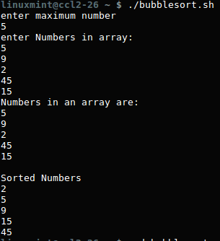

8.
echo "enter first number"
read a
echo "enter second number"
read b
echo "a before swapping is $a and b is $b"
#swapping
a=$((a+b))
b=$((a - b))
a=$((a-b))
echo "a after swapping is $a and b is $b"

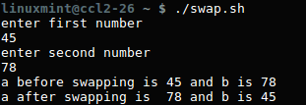

9.
echo "enter maximum number"
read n
echo "enter Numbers in array:"
for (( i = 0; i < $n; i++ ))
do
read nos[$i]
done
echo "Numbers in an array are:"
for (( i = 0; i < $n; i++ ))
do
echo ${nos[$i]}
done

for (( i = 0; i < $n ; i++ ))
do
for (( j = $i; j < $n; j++ ))
do
if [ ${nos[$i]} -lt ${nos[$j]} ]; then
t=${nos[$i]}
nos[$i]=${nos[$j]}
nos[$j]=$t
fi
done
done
echo -e "\nSorted Numbers "
for (( i=0; i < $n; i++ ))
do
echo ${nos[$i]}
done

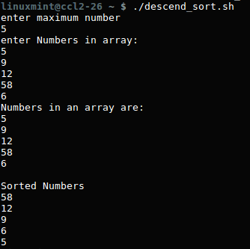

10.
echo "enter maximum number"
read n
echo "enter Numbers in array:"
for (( i = 0; i < $n; i++ ))
do
read nos[$i]
done
echo "Numbers in an array are:"
for (( i = 0; i < $n; i++ ))
do
echo ${nos[$i]}
done
for (( i = 0; i < $n ; i++ ))
do
for (( j = $i; j < $n; j++ ))
do
if [ ${nos[$i]} -gt ${nos[$j]} ]; then
t=${nos[$i]}
nos[$i]=${nos[$j]}
nos[$j]=$t
fi
done
done
echo -e "\nSorted Numbers "
for (( i=0; i < $n; i++ ))
do
echo ${nos[$i]}
done

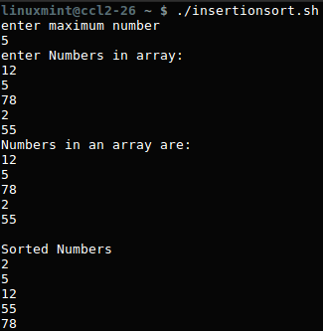

11.

echo "enter the size of array"
read n
echo "enter number in an array"
for((i=0;i<n;i++))
do
read arr[$i]
done
#logic for selection sort
for((i=0;i<n-1;i++))
do
small=${arr[$i]}
index=$i
for((j=i+1;j<n;j++))
do
if((arr[j]<small))
then
small=${arr[$j]}
index=$j
fi
done
temp=${arr[$i]}
arr[$i]=${arr[$index]}
arr[$index]=$temp
done
echo "printing sorted array"
for((i=0;i<n;i++))
do
echo ${arr[$i]}
done

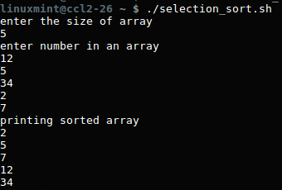

12.

N=16
a=0
b=1

echo "The Fibonacci series is : "

for (( i=0; i<N; i++ ))
do
echo -n "$a "
fn=$((a + b))
a=$b
b=$fn
done

13.
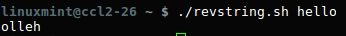
input="$1"
reverse=""

len=${#input}
for (( i=$len-1; i>=0; i-- ))
do
reverse="$reverse${input:$i:1}"
done

echo "$reverse"

14.
echo "Enter a string to be checked:"
read str
echo
len=`echo $str | wc -c`
len=`expr $len - 1`
i=1
j=`expr $len / 2`
while test $i -le $j
do
k=`echo $str | cut -c $i`
l=`echo $str | cut -c $len`
if test $k != $l
then
echo "String is not palindrome"
exit
fi
i=`expr $i + 1`
len=`expr $len - 1`
done
echo "String is palindrome"
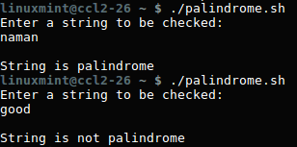

15.

pow()
{
a=$1
b=$2
c=1
res=1

if((b==0));
then
res=1
fi

if((a==0));
then
res=0
fi

if((a >= 1 && b >= 1));
then
while((c <= b))
do
res=$((res * a))
c=$((c + 1))
done
fi

echo "$1 to the power $2 is $res"
}

A=2
B=4
pow $A $B

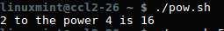

16.
i=1
while((i<=500))
do
c=$i
d=$i
b=0
a=0
while((c>0))
do
a=$((c%10))
b=$((b + a*a*a))
c=$((c/10))
done
if((b==d)); then
echo "$i"
fi
i=$((i+1))
done

